*Week 4 (16/10/2020): Noughts and Crosses*

*1.0 Introduction:*

The game created is from the foundation of the classic noughts and crosses, however there is a chance mechanic that will change the gameplay entirely. The skill of noughts and crosses with the chance of anything to happen. The game is modified to include a random event to occur. It ranges from an extra turn to the entire board wiped; events are chosen by chance. Gameplay is round based, a best of 3 or 5 per game. There is also a clear winning condition, the player who won most rounds

*1.1 Materials:*

We needed 2 different types of materials in order for our game to be made. The first would be a spinning wheel for our “chance” mechanic. The other would be a sketching board for us to draw out the grid as well as to play the game. These were found online on different websites.

*1.2 Rules:*

This game can only be played by 2 players at most. A coin will be flipped to decide who the starting player will be. At the start of each match, the grid will be 3 by 3. Players will get to decide what their symbols will be, either “X” or “O”. To balance out gameplay, players will take turns putting their marks in empty squares. The first player to get 3 of their marks in a row (horizontal, vertical or diagonal) is the winner. However, when all squares are occupied, the game will result in a tie.

*2.0 How the game functions:*

We implemented a “chance” mechanic into our game. After a player has ended their turn, a wheel containing events is spun. The chosen event will immediately apply into the current gameplay. The wheel can only be spun once per player’s turn.

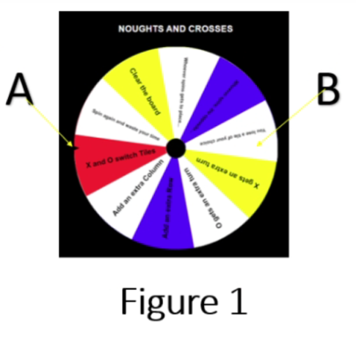

**Figure 1:** Here is the wheel spinning mechanic. “A” is the counter that determines the event after a wheel spin and “B” is an example of an event

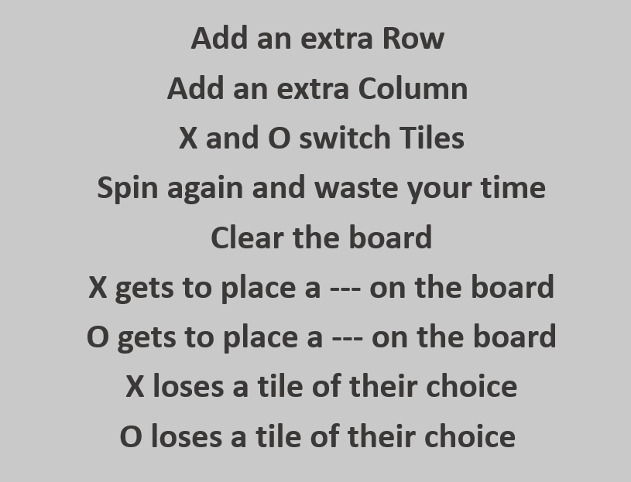

**Figure 2:** The above examples of the events on the wheel which will be spun by the players after each turn. Once an event is chosen, it will translate into the current game.

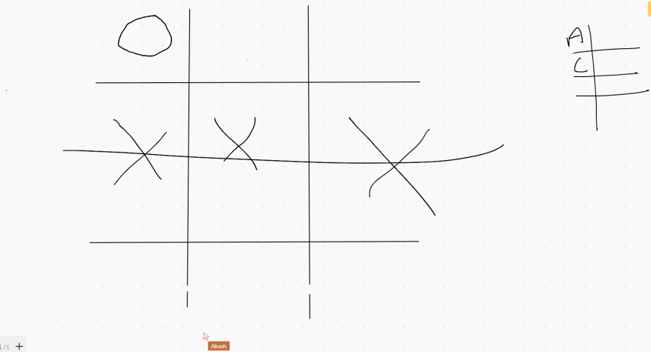  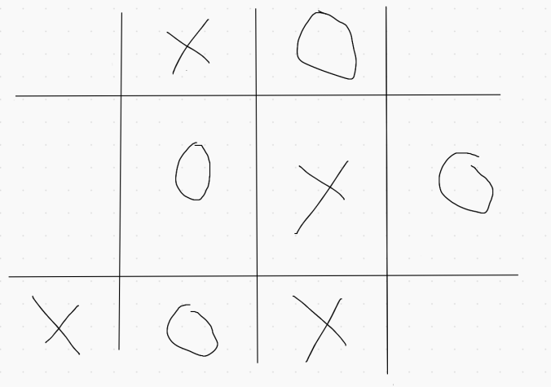

**Figure 3 & 4:** The images above display examples of how the game was played as well as showing how the events changes the flow of the game.

*3.0 Game Testing:*

We managed to do both internal and external game testing. We started off with internal testing to spot out any issues before handing it over to other groups to test. We found out that the game ended too quick due to the event wheel. This is because players can get lucky and have the wheel land on an “X loses a tile of their choice” in the first round and would result in immediate win for the opposing. As for external game testing, another group found that some of the events were too unbalanced as per mentioned before. With 2 parties agreeing on the same issue, we took a look back at our events and tweaked some of them as well as removing any unnecessary events.

*4.0 References:*

<https://awwapp.com/b/ubuyyuvatj5yd/#>